Administrative Supplier Change
An administrative supplier change could be that we have to request a new Parma number for an existing supplier due to e.g. changed VAT no. Or it could be a new company buying out the current company/supplier that we purchase parts from. When this is happening we need to switch master data (Info Records, Scheduling Agreements, Source Lists) and PDS data from current Parma to this new Parma. In reality the production facility is not changing and parts are still going to be supplied from same production facility with under new organization/company.

 | Make sure that the Vendor Master is created for all POrgs/Plants prior to executing the Admin Parma change

 | Important! This activity type cannot be used if any master data records (Info record, Scheduling Agreement or Source List) already exists with the new supplier. If that’s the case, manual update of master data must be done and QA must be informed as the deliveries from the new supplier will be flagged for inspection.

- Open transaction ZMFMB2010, Project Control

- In the initial screen, press the button ‘Create Project’:

- Enter Activity Type (PAR) and GTC and press ‘Enter’:
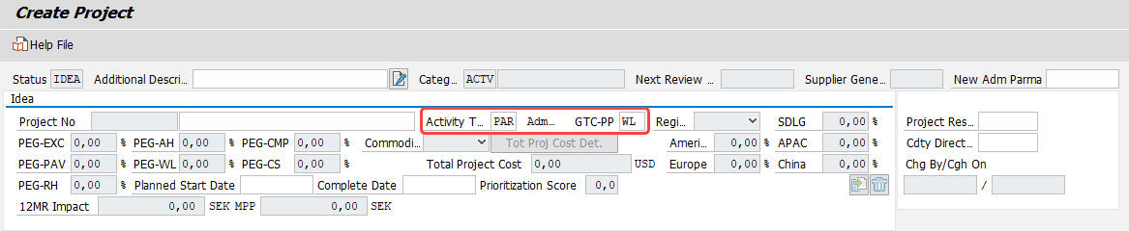

- Enter the following information in IDEA stage:
- Project Description
- New Adm Parma (New Vendor Parma number)
- Project Responsible and Commodity Director
- Planned Start Date
- Complete Date
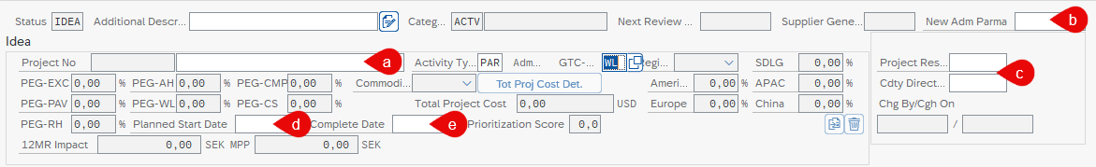

- Enter part number details, preferably by using the Select-options function:
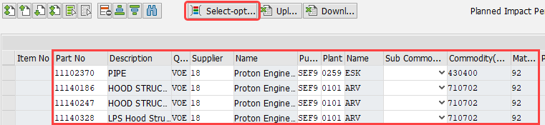

 | Make sure to only include active parts in your project, i.e. pay attention to the material status and info record/scheduling agreement status.

 | Detailed instruction for how to add item details via ‘Select options’

- For each part number, make a selection in the field New-Existing SA:
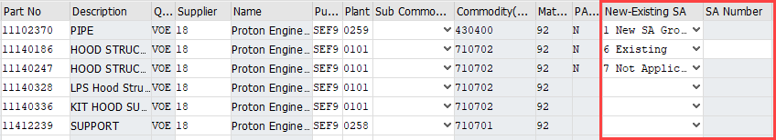

- If a new Scheduling Agreement shall be created and all parts should be on one SA with the new supplier, select 1 New SA Group1 for all parts.
NOTE: If you have different plants you need to put parts on different SA, for example:
  - New SA Group 1 for plant 0259
  - New SA Group 2 for plant 0101
  - New SA Group 3 for plant 1222
  - Etc.

If you want to put the parts on different SAs with the new supplier, select 1 New SA Group1 for the parts going on SA no 1, 2 New SA Group2 for the parts going on SA no 2 etc.
- If you want to add the parts on an existing SA, select 6 Existing and enter SA number

- If no SA should be created, select 7 Not Applicable

 | Please note! For plant 5161 there is a setting allowing a maximum amount of parts (50) on one SA. For this plant the selection should always be 1 New SA Group1 for all parts. The system will automatically generate a new SA when the max amount has been reached.

 | For projects containing a lot of part numbers it is recommended to download the data to excel, make the entry for New-Existing SA in the file and then upload it to the project.

- In the Committed stage, enter Effective Date (this is date from which the source list will be valid, must be later than today’s date):

- Press to save

- Press ‘Yes’ to continue:
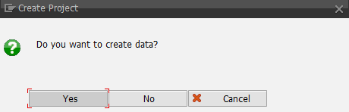

- A confirmation message will appear at the bottom of the screen:

- To process the Admin Parma Change, return to the initial selection screen, select the line and press the button ‘Process Project’:
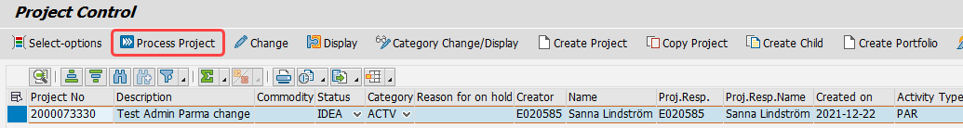

- Press the button ‘Execute Admin Parma Change’:
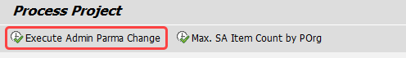

 | Please note that the system will execute the change for all part numbers in the project., it is not possible to just select a few item lines.

Press ‘Yes’ to continue:
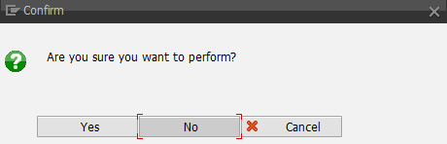
- A confirmation message will appear at the bottom of the screen:

- The result of the update for each part number will be displayed like below:

- If the checkbox is ticked, the master data has been successfully created

- For PDS the following will apply:
- If APQP exists for the part number/current Parma, this will be copied for the new Parma. If the APQP for the current Parma is closed, the system will automatically close the APQP for the new Parma as well with a reference comment to Admin Parma change.
If the APQP for the current Parma is open, the system will copy the APQP for the new Parma but it will remain open with the same status as for the copied APQP.
- If no APQP exists for the part number/current Parma, a stand-alone APQP with PPAP level 05 will be created for the new Parma, and it will be automatically closed with a reference comment to Admin Parma change.

 | If an error occurred during the update, the checkbox will not be ticked and a comment related to the error will be displayed in the Remark field.  You then need to check the data, adjust if necessary, and execute the Admin Parma change again.  Important! Do NOT create master data manually as that will prevent the system from creating PDS data, and the MPP will not be completed.

- For plants not using PDS and/or Source List, the MPP will stay in status IDEA and must be completed manually. This needs to be requested by creating a support request at Purchasing Support.

- When all updates are done, the MPP status will change to CMPL and the completion date will be filled:
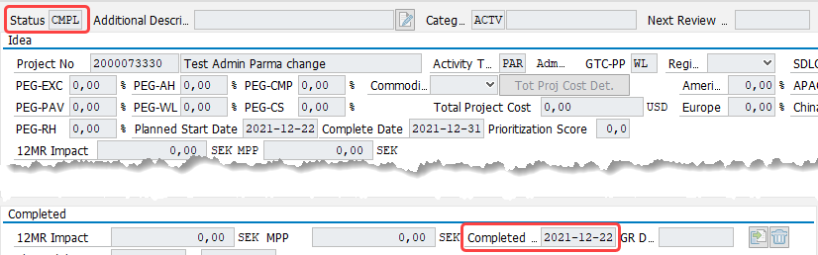

 | Important! Secure that the MPP is completed at the same day as the execution, or in the next coming days, as parts will stop at QA at first delivery if MPP isn’t completed.

 | Remember! You need to manually close the master data (including open RFQs and APQPs) for the “old” supplier in SAP once the final switch has been done.  Close master data for old supplier in SAP in relation to supplier switch

